Notice
- Breakfast is served in hotel. Lunch is served in class room. Dinner is served in hotel rooms.
- Only accommodation fee and expense of meals shall be covered by DFH Satellite Company.
- Shuttle bus leaves the hotel at 8:30 am and leaves the class room at 4:45 pm.
Information
- Organizer
Name | Address | Telephone
DFH Satellite Co,. Ltd.  航天东方红卫星有限公司 | 104# Youyi Road, Haidian District, Beijing 北京市海淀区友谊路104号 | 010-68745088

- Hotel
Name | Address | Telephone
Free Comfort Holiday Hotel（Xi Shan）  北京康福瑞连锁酒店（西山店） | 13#, ZhiFeng East Road, Haidian District,北京市海淀区丰智东路13号 | 010-62076207

- Contacts
Name | Cellphone Number
Mr. Yang Dong | +8613810069213
Mrs. Hou Tianbao | +8613581870228

1. Food
Breakfast is served from 7:00 am to 8:30 am at the second floor of hotel.
Lunch is served in class room.
Dinner is served in hotel rooms.
The food provided by hotel, except breakfast, shall be paid by the trainee.
2. Transportation
Shuttle bus shall be provided during the workdays of training.
In the morning, the pickup point is at the gate of hotel. The departure time is 8:30 am. Please arrive 10 minutes earlier to get ready. This will allow the bus to leave on time.
After class, the pickup point is at the gate of class room. The courses usually finish at 4:30 pm depending on individual progress and the departure time is 4:45 pm.
We will notify you in advance if there are any changes.
Please take the shuttle bus on time. Trainees are responsible for their own transportation to the class if missed the bus.

3. Accommodation
If you need help about accommodation, please call the hotel reception （dial 88802 by room telephone）.
Additional service fee, such as meals expenses except breakfast in hotel shall be paid by trainee.
4. Your Rights & Responsibilities
- It is expected that behavior in class ensures a positive learning and teaching environment.
- Take good care of your belongings including passport, wallet, keys and other valuable items during your staying.
- Be careful of dietary safety when you dine out alone.
- Please do not hesitate to contact us when you are not feeling well. Call us or the following number if there is any emergency.

Emergency Center 120/999 | Fire Alarm  119 | Traffic Accident  122 | Police  110

Date | Time | Content
Oct 8th  Tuesday | 09:00-12:00 | Satellite safe modes ETRSS-1
 | 13:30-16:30 | Satellite safe modes ETRSS-1
Oct 9th  Wednesday | 09:00-12:00 | OBDH In-orbit operation instructions
 | 13:30-16:30 | OBDH In-orbit operation instructions
Oct 10th  Thursday | 09:00-12:00 | Telemetry interface operation and confirmation
 | 13:30-16:30 | PSS In-orbit operation instructions
Oct 11st  Friday | 09:00-12:00 | PSS In-orbit operation instructions
 | 13:30-16:30 | Telemetry interface operation and confirmation
Oct 12nd  Saturday | 09:00-12:00 | TT&C In-orbit operation instructions
 | 13:30-16:30 | TT&C In-orbit operation instructions
Oct 14th  Monday | 09:00-12:00 | Telemetry interface operation and confirmation
 | 13:30-16:30 | AOCS In-orbit operation instructions
Oct 15th  Tuesday | 09:00-12:00 | AOCS In-orbit operation instructions
 | 13:30-16:30 | Telemetry interface operation and confirmation
Oct 16th  Wednesday | 09:00-12:00 | DTS In-orbit operation instructions
 | 13:30-16:30 | Multispectral camera in-orbit operation instructions
Oct 17th  Thursday | 09:00-12:00 | In-orbit operation management procedure
 | 13:30-16:30 | Questions and answers
Oct18th  Friday | 09:00-12:00 | Examination
 | 13:30-16:30 | Closing ceremony
5. Training Schedule
6. Maps
Training Site

Training site: DFH Satellite Co,. Ltd.航天东方红卫星有限公司综合楼321室
Address: 102# Youyi Road, Haidian District, Beijing北京市海淀区友谊路102号综合楼

Bus stop: 600 meters distant
Hang Tian Cheng Station 航天城公交站Bus447, Bus205（6:00am-10:00pm）

Pharmacy: 500 meters distant
Tong Ren Tang Pharmacy 同仁堂药店（24H）

Supermarket: 600 meters distant
Chao Shi Fa Supermarket 超市发超市（9:00am-9:00pm）

Bank: 500 meters distant
Agricultural Bank of China中国农业银行 （9:00am-5:00pm）

Hospital: 4000 meters distant
Peking University International Hospital北京大学国际医院（24H）

Hotel Site

Your Hotel: Free Comfort Holiday Hotel（Xi Shan）
北京康福瑞连锁酒店（西山店）
Address: 13#, Zhi Feng East Road, Haidian District, Beijing.
北京市海淀区丰智东路13号
Hotel Telephone: 010-62076207

Subway station: 400 meters distant
Line 16, Yong Feng Nan Station永丰南站（6:00am-10:55pm）

Pharmacy: 30 meters distant
Xin Kang Tang Pharmacy 信康堂药店（8:00am-11:00pm）

Muslim Restaurant: 20 meters distant
Lanzhou Lao ma noodle restaurant 兰州老马拉面（10:30am-01:00am）

Telecom Business Hall: 800 meters distant
China Telecom中国电信（9:30am-7:00pm）

Bank: 50 meters distant
Bank of Beijing 北京银行（9:00am-5:00pm）

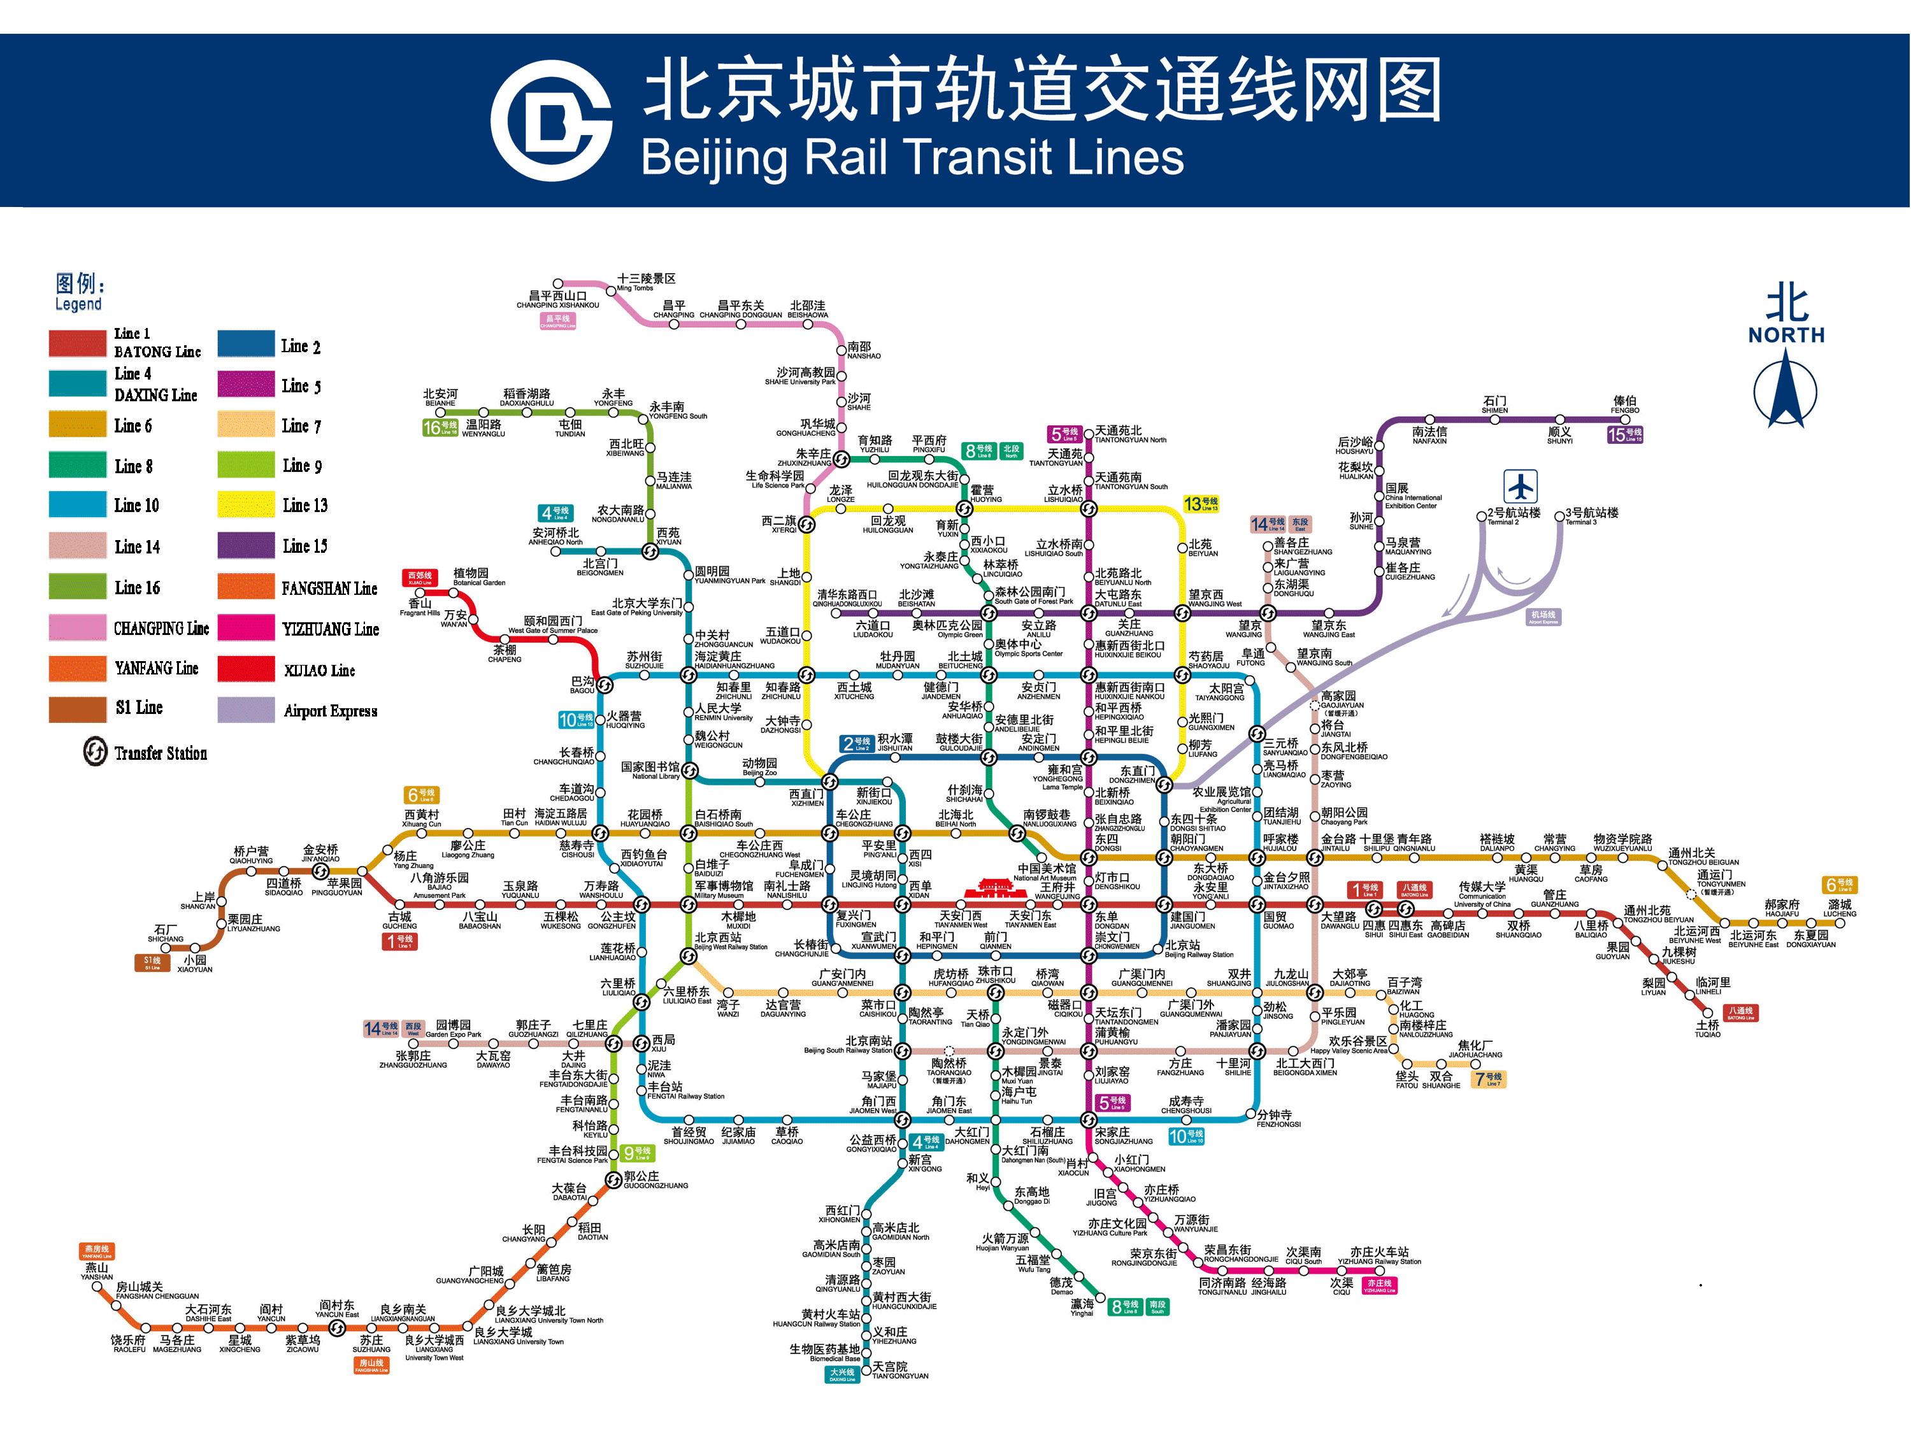

Transportation fees reference
Landmark | Distant | By Taxi  （Time and Cost） | By Subway  （Time and Cost）
Tian An Men Square/CBD | 30km | 60minutes/100RMB | 70minutes/6RMB
Hong Qiao Market | 40km | 90minutes/110RMB | 80minutes/6RMB
Wu Daokou area | 16km | 40minutes/50RMB | 60minutes/5RMB
Airport | 45km | 70minutes/120RMB | 100minutes/31RMB

